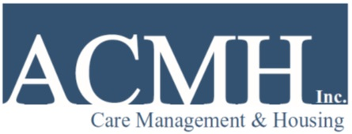
POSITION ANNOUNCEMENT

Position: Peer Program Specialist- Manhattan, Bronx, & Queens Positions Available

Reports to: Program Director
Function: Provides direct service to clients in their homes, assisting with training in skills of daily living.

Tasks:
- Teaches skills for maintaining personal hygiene, laundry and apartment cleaning.
- Monitors overall maintenance of apartments and alerts program director of maintenance problems.
- Teaches skills for budgeting, shopping, meal planning, preparation and clean-up.
- Teaches skills for self-preservation, monitors living units for safety and cleanliness.
- Administers the client cooking safety test.
- Monitors, documents and teaches self administration of medication, according to program policy and procedures.
- Report incidents or behavioral changes in residents to supervisor.
- Teaches travel skills and escorts clients, where needed.
- Facilitates/co-facilitates groups, as requested.
- Documents services rendered and client progress in a timely manner.
- Attends training as requested by supervisory staff.
- Duties as assigned by supervisor.

Qualifications: Lived experience receiving mental health services and a commitment to assist others in attaining recovery and wellness goals. High School diploma or G.E.D. preferred. Good written and verbal communication skills in English. Basic computer and data entry skills.

Salary: $36,768 - $39,167 plus generous benefits

Fax/mail/email a resume, cover letter and contact information for 3 professional references to:

Sharon Royer
Director of Human Resources
Fax: (212)925-7958
Email: sroyer@acmhnyc.org

ACMH is committed to the mental and physical wellbeing of vulnerable New Yorkers and is a leader in the provision of outreach and engagement, care management, rehabilitation, and supportive housing.

For more information, visit our website: www.acmhnyc.org

