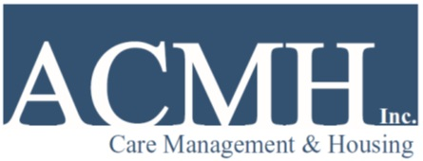
POSITION ANNOUNCEMENT
Position: Addictions Specialist, The Grand
Reports to: Program Director
Function: Delivers recovery oriented, harm reduction services to individuals who have substance use and/or co-occurring disorders. Serves as a consultant to other staff members providing training as indicated.

Tasks:
- Participates as an active member of the residential team in developing and implementing person-centered recovery-oriented treatment plan goals and objectives.
- Collaborates with program director to identify participants.
- Provides recovery and education services on an individual and group basis for clients with substance use and co-occurring disorders.
- Provides functional skills and substance use assessments in order to develop individualized needs-based plans congruent with client needs, preferences, goals and readiness.
- Establishes and maintains liaison with primary provider of medical, psychiatric and substance use treatment.
- Liaises and makes appropriate referrals to in-patient and outpatient substance use treatment and support groups.
- Administers standardized health screening tools.
- Documents client response to services, progress and regressions, and provides ongoing feedback to client and program team.
- Facilitates crisis intervention in the event of an emergency.
- Submits necessary notes and reports, including incident reports, in compliance with agency procedures.
- Develops and maintains a resource guide for clients and staff on substance use treatment and support programs.
- Provides consultation and coordination for in-staff training and support on addiction related services for the program team.
- Attends in-service training as requested by supervisory personnel.
- Duties as assigned by supervisor.

Qualifications:
M.A. in psychology or a human services related field with extensive experience working with adults with substance use disorders and/or co-occurring disorder. Strong written and verbal communication skills with knowledge of evidence based and harm reduction practices in substance use treatment. Ability to meet with residents and staff across multiple sites. CASAC preferred.

Salary: $59,024 - $63,240 plus generous benefits

Email a resume, cover letter and contact information for 3 professional references to:

Aisha Silla
Senior Director for Residential and Recovery Services
Email: isilla@acmhnyc.org

ACMH is committed to the mental and physical wellbeing of vulnerable New Yorkers and is a leader in the provision of outreach and engagement, care management, rehabilitation, crisis support, and supportive housing. ACMH seeks to promote actionable change to create an intentional culture of equity at individual, interpersonal and institutional levels.

For more information, visit our website: www.acmhnyc.org

